Quantum Neural Network Approach to Behavioral Fraud Detection Using Timing and Categorical Financial Features

Farheen Shabbir Shaikh
Department of School of Engineering & Computer Science
University of the Pacific
Stockton, California, USA

ORCID:orcid.org/0009-0009-7022-7810

Abstract—Advanced-Fee Fraud (AFF) scams often oppress victims into making rapid upfront payments, making it a critical behavioral indicator for early detection. In this research, we investigate how accurately and how quickly a Quantum Neural Network (QNN) can detect and classify AFF attacks using behavior-based features, and compare its performance against classical machine learning models. Initial experiments on a synthetic financial dataset show that all models, quantum and classical, are constrained in accuracy when only a single feature is used; the QNN shows classification performance comparable to Logistic Regression, while SVM can overfit and appear artificially strong. However, SVM exhibits increased classification speed when the feature is included, whereas QNN inference remains significantly slower due to the cost of quantum circuit simulation. As part of this research, we also evaluate the QNN’s suitability for AFF detection and outline how its performance could be further improved by encoding additional categorical and numerical fraud indicators with more qubits in future work.

Keywords—Advanced-Fee Fraud (AFF), Quantum Neural Network (QNN), Support Vector Machine (SVM), Inter-Payment Interval (IPI), fraud detection, classification speed, quantum machine learning, feature encoding, categorical features, numerical features, anomaly detection.

Introduction
Financial fraud has evolved into one of the fastest-growing global cyber risks, with attackers increasingly leveraging psychological manipulation and high-pressure communication tactics to coerce victims into making rapid, irreversible
payments. Among these schemes, Advance-Fee Fraud (AFF) stands out for its ability to exploit urgency: victims are often persuaded to send money within minutes of receiving a
deceptive message. This compressed timeline creates a critical vulnerability—traditional fraud-detection systems often cannot react quickly enough to intervene before the first payment is made. Understanding and modeling these rapid behavioral patterns is therefore essential for developing early-warning systems capable of preventing loss.
Over the past five years, the Federal Bureau of Investigation’s Internet Crime Complaint Center (IC3) has received an average of more than 836{,}000 cybercrime complaints annually, underscoring the escalating scale and diversity of online . Within this landscape, Advance-Fee Fraud (AFF) remains a persistent and economically damaging threat. Although AFF ranks lower in complaint volume compared to phishing or extortion—recording 7097 complaints in 2024—it generates disproportionately severe financial losses, exceeding $102 million in 2024 alone. Historical IC3 records further show that AFF losses consistently surpass $100 million annually, including a peak of $134 million in 2023, highlighting its continued impact. Demographic analyses also reveal that AFF affects victims across all age groups, with individuals aged 30–59 reporting both the highest complaint counts and the largest cumulative losses. Additionally, AFF schemes appear within cryptocurrency-enabled crime, contributing 1537 complaints and more than $36 million in losses, demonstrating the scam’s evolution alongside modern financial platforms. Collectively, IC3 data indicate that AFF is both widespread and highly lucrative for attackers, reinforcing the urgent need for real-time behavioral analytics and advanced detection models such as Quantum Neural Networks (QNNs).
One of the most informative behavioral indicators in AFF scenarios is the [], defined as the time gap between the scam message and the first outgoing payment. Shorter IPIs strongly correlate with attacker-induced urgency, making this feature a powerful candidate for early fraud detection. However, the challenge lies in determining whether machine learning models—both classical and quantum—can effectively leverage such a minimal behavioral feature to identify AFF activity in real time.
Quantum Machine Learning (QML) has emerged as a promising research direction, offering the potential for expressive decision boundaries and efficient computation on future quantum hardware. Yet, despite growing interest, little is known about how Quantum Neural Networks (QNNs) perform on practical, small-scale behavioral fraud-detection tasks, and how their classification speed compares with classical baselines such as Support Vector Machines (SVM) and Logistic Regression. Speed is not merely a performance metric; in financial transaction systems, milliseconds can determine whether a fraudulent payment is intercepted before completion.

This research investigates both the accuracy and classification speed of a QNN relative to classical models using IPI as the primary behavioral feature for AFF detection. By benchmarking accuracy and inference latency across quantum and classical architectures, this work aims to clarify the realistic capabilities of QML in fraud analytics and establish a foundation for future studies that incorporate richer categorical and numerical features encoded into additional qubits.

Motivation
Advance-Fee Fraud (AFF) attacks remain one of the most pervasive and financially damaging forms of cybercrime, largely because scammers exploit psychological urgency to pressure victims into making rapid, unverified payments. This behavior creates an exceptionally narrow detection window, making the Inter-Payment Interval (IPI)—the time between the scam message and the first payment—a critical early indicator of fraud. Detecting unusually short IPIs in real time could significantly reduce financial losses; however, classical machine-learning models often underfit in this setting because behavioral features are sparse and datasets are small. While models such as Logistic Regression and Support Vector Machines (SVM) offer speed and stability, their ability to generalize from limited behavioral cues is constrained. Quantum Neural Networks (QNNs), in contrast, promise richer decision boundaries using fewer features, but their practical accuracy and inference speed in time-sensitive fraud-detection tasks remain insufficiently explored. This gap motivates the present study, which evaluates whether QNNs can effectively detect AFF using minimal behavioral inputs and whether their classification latency can meet the millisecond-level requirements of real-time financial systems—an essential step toward developing next-generation fraud-detection pipelines.

Literature Review

Advance-Fee Fraud (AFF) and Behavioral Indicators
Advance-Fee Fraud (AFF) is a widely documented social-engineering scheme in which offenders manipulate victims into sending upfront payments under deceptive pretenses. Leukfeldt and Jansen [1] explain that AFF victimization follows a psychological progression involving trust-building, urgency induction, and staged financial requests. Social-engineering research further reveals that attackers deliberately exploit emotional pressure, perceived authority, and time scarcity to impair rational decision-making [2].
A key behavioral signal relevant to early detection is the Inter-Payment Interval (IPI)—the time between receiving a fraudulent message and initiating the first payment. Prior work demonstrates that temporal response patterns are highly effective indicators of fraud susceptibility, especially in high-pressure scams where victims react within minutes [3]. This motivates the use of IPI as a core numerical–behavioral feature for detecting AFF in real time.

Classical Machine Learning Approaches to Fraud Detection
Classical machine learning has been widely applied to financial fraud analytics due to its efficiency and stability. Anusha and Amutha [4] provide a comprehensive review showing that models such as Logistic Regression (LR) and Support Vector Machines (SVM) are commonly used because of their interpretability and low computational cost.
LR, grounded in statistical learning theory [5], offers fast inference but is constrained by its linear decision boundaries, making it less effective in cases involving nonlinear behavioral signals. Similarly, Hosmer et al. [6] highlight LR’s sensitivity to feature scaling and its limitations with small or imbalanced datasets.
SVMs, introduced by Vapnik [5], provide stronger nonlinear modeling capabilities when kernel functions such as the radial basis function (RBF) are used. However, inference latency increases with the number of support vectors, which may hinder real-time fraud detection when behavioral features are sparse or rapidly evolving.

Quantum Machine Learning and the Emergence of QNNs
Quantum Machine Learning (QML) has gained momentum as a potential alternative to classical models, especially for tasks involving complex decision boundaries. Schuld et al. [7] describe the conceptual foundations of quantum neural networks (QNNs), highlighting their ability to embed data into high-dimensional Hilbert spaces.
More recent work by Schuld and Killoran [8] formalizes the use of feature Hilbert spaces for quantum learning, enabling classical features to be encoded directly into quantum states. Abbas et al. [9] further demonstrate that QNNs can express highly nonlinear functions with fewer trainable parameters than deep neural networks, suggesting potential advantages for fraud detection when feature sets are compact.

Parametrized Quantum Circuits (PQCs)
Parametrized Quantum Circuits (PQCs) serve as the core computational units of QNNs. Preskill [10] emphasizes that PQCs are particularly suited to the Noisy Intermediate-Scale Quantum (NISQ) era due to their hybrid design and compatibility with classical optimization.
Bergholm et al. [11] show that modern frameworks such as PennyLane enable automatic differentiation across quantum and classical components, making PQCs practical for supervised fraud-detection tasks. Additionally, Lloyd et al. [12] demonstrate that quantum circuits can be trained for classification through variational optimization, providing a mechanism for QNN-based decision-making.

Fraud Landscape and Motivation for Real-Time Detection
The 2024 Internet Crime Report [13] highlights that financial fraud continues to grow in scale, with losses increasingly driven by fast-moving scams such as AFF. Since many victims respond within minutes of initial contact, detection systems must operate within strict latency constraints.
Furthermore, visual models of the social-engineering attack lifecycle [14] illustrate how psychological manipulation unfolds across distinct stages. This progression reinforces the need for behavior-aware detection—particularly the use of timing-based features such as IPI—to identify AFF before payment occurs.

Background

Advanced-Fee Fraud (AFF) and Behavioral Indicators
Advance-Fee Fraud (AFF) is a form of social-engineering attack in which scammers persuade victims to transfer money upfront under false pretenses (Leukfeldt & Jansen, 2020). AFF techniques follow the broader psychological manipulation cycle used in social engineering: attackers investigate the victim, establish a persuasive hook, execute the fraudulent play, and finally exit while covering their tracks. These interactions rely heavily on urgency cues, emotional pressure, and manufactured opportunity, all of which significantly reduce a victim’s decision-making time (Hadnagy, 2018).
A key behavioral signal arising from this manipulation is the Inter-Payment Interval (IPI), a numerical–behavioral hybrid feature representing the time elapsed between receiving the scam message and sending the first payment. Prior research shows that urgency-driven attacks shorten victim response time and therefore require temporal features for effective early-stage fraud detection (Narayanan et al., 2019). In AFF scenarios, modeling such timing behavior is essential for detecting the scam before monetary loss occurs. A visual illustration of the social-engineering lifecycle is shown in Image 1.
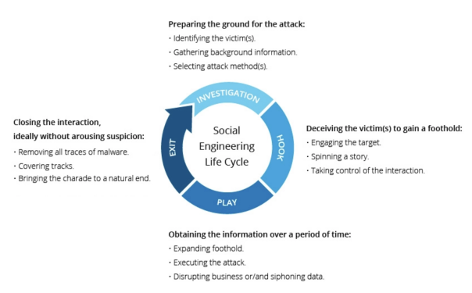
Image 1: The Social Engineering Lifecycle illustrating the stages of an AFF-style scam.

Classical Machine Learning for Binary Classification
Classical machine-learning models are widely used in fraud analytics due to their efficiency, robustness, and interpretability[3].

Logistic Regression (LR) : Logistic Regression models the probability of a binary outcome using a logistic function [7]. Although computationally lightweight, LR is limited to learning linear decision boundaries and may underperform when fraud patterns exhibit nonlinear relationships.

Support Vector Machine (SVM): Support Vector Machines project data into higher-dimensional spaces to find an optimal separating hyperplane [5]. When paired with nonlinear kernels such as the RBF kernel, SVMs can model complex decision boundaries even in small datasets. However, inference time depends on the number of support vectors, causing classification speed to vary based on feature selection and model complexity.

Quantum Machine Learning and Quantum Neural Networks

Quantum Machine Learning (QML) integrates quantum computation with classical optimization methods and has gained interest for its potential to learn complex patterns using compact representations (Schuld et al., 2014). This study employs a Quantum Neural Network (QNN) based on Parametrized Quantum Circuits (PQCs).

Parametrized Quantum Circuits (PQCs) : PQCs consist of trainable quantum gates applied to qubits, combined with feature-encoding rotations that embed classical data into the quantum state space (Schuld & Killoran, 2019). During training, the parameters of these gates are optimized to minimize a classical loss function. Encoded features E(x) pass through a variational circuit U(\theta), whose measurement outcomes provide expectation values used by the QNN. By leveraging the high-dimensional Hilbert space of quantum states, QNNs may capture complex decision boundaries even with a small number of input features. Figure 2 presents the PQC architecture used in this study, demonstrating the flow from classical features to quantum encoding, variational layers, measurement, and final classification output.

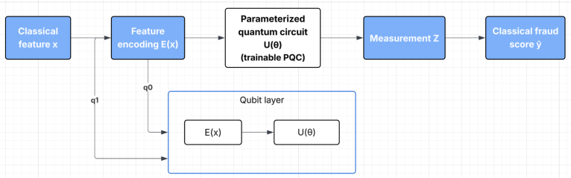
Image 2: Parameterized Quantum Circuit (PQC) architecture used in this study. Classical features—such as the Inter-Payment Interval (IPI) and additional numerical fraud indicators—are first encoded into qubit rotations. These encoded features are then processed by a trainable variational quantum circuit U(θ). The resulting quantum state is measured to obtain expectation values, which are converted into a classical fraud score ŷ.

Quantum Feature Encoding : Each input feature is embedded into a qubit through rotation gates. Increasing the number of features increases circuit depth and the number of quantum operations. Since circuit depth directly affects computational complexity, QNN inference time scales with the number of encoded features.

Quantum Simulation Overhead : Because current experiments run on classical hardware rather than true quantum processors, simulation cost scales exponentially with qubit count and circuit depth []. Frameworks such as PennyLane allow hybrid quantum-classical modeling but inherit these simulation constraints, resulting in significantly slower inference times than classical machine-learning models [11].

Methodlogy
This study evaluates the capability of a Quantum Neural Network (QNN) to detect Advance-Fee Fraud (AFF) using minimal behavioral features, and compares its performance against two classical baselines: Logistic Regression (LR) and Support Vector Machines (SVM). The methodology consists of four main components: dataset construction, feature engineering, model design, and evaluation protocols.

Dataset Construction
A total of N = 50 synthetic samples were generated to simulate early-stage financial interactions. To more realistically reflect the rarity of real-world AFF cases, the dataset was intentionally imbalanced, consisting of 40 non-fraud cases (80%) and 10 fraud cases (20%). Fraudulent samples were assigned short IPI values (1–10 minutes) to mimic urgency-driven manipulation, while non-fraud samples exhibited longer IPI intervals (20–60 minutes). Additional numerical indicators were drawn from uniform distributions to represent common low-magnitude financial fluctuations. All features were normalized to the [0,1] range prior to model training.
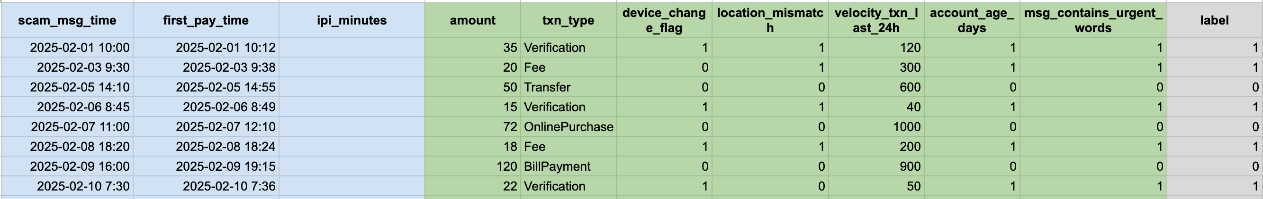
Image 3: Sample of the constructed synthetic AFF dataset showing behavioral, transactional, and contextual features used for model training. Each row represents a simulated user interaction, including scam message time, first payment time, the Inter-Payment Interval (IPI), transactional metadata, device and location anomaly flags, and the final fraud label (0 = non-fraud, 1 = fraud)
This dataset includes several behavioral and numerical indicators commonly associated with Advance-Fee Fraud (AFF) patterns:

- Inter-Payment Interval (ipi_minutes): The primary behavioral feature representing how quickly a victim responded to a scam message. Shorter IPIs indicate urgency-driven manipulation and are highly predictive of fraud.
- amount: The transaction amount associated with the first payment attempt. Lower amounts may indicate “verification” tests, while moderate amounts reflect typical upfront-fee requests.
- txn_type: Categorizes the nature of the transaction (e.g., Verification, Fee, Transfer). Certain types—such as Fee or Verification—are strongly associated with early-stage AFF behaviors.
- device_change_flag: A binary indicator capturing whether a device change occurred before the transaction. AFF attacks sometimes involve new or compromised devices.
- location_mismatch: Signals whether the user’s transaction location differs significantly from their usual pattern. This is a common fraud-risk signal.
- velocity_txn_last_24h: Measures recent transaction burstiness. Unusually high transaction velocity may indicate automated or pressured activity.
- account_age_days: Newly created accounts are more vulnerable and often targeted by scammers. Low values raise risk.
- msg_contains_urgent_words: Indicates whether the scam message contained urgency cues (e.g., “immediately,” “final notice,” “confirm now”). These cues strongly correlate with shorter IPIs and AFF victimization.
- label: The binary ground truth indicating whether the interaction corresponds to an Advance-Fee Fraud attempt (1) or legitimate behavior (0).
Each data point represents a single interaction consisting of:
- Inter-Payment Interval (IPI): the time (in minutes) between the scam message and the victim’s first payment.
- Additional numerical indicators: randomly generated financial features such as small transaction attempts, user balance changes, or anomaly scores (included in extended experiments to evaluate QNN scalability).
Binary class labels were generated as follows:
- 1 = Fraud (AFF)
- 0 = Not Fraud
Fraud cases were parameterized to exhibit shorter IPI values, reflecting urgency manipulation. Non-fraudulent instances were assigned longer, more variable IPI values. The dataset was split into:
- 70% training
- 15% validation
- 15% testing

Feature Engineering
Two sets of experiments were performed:

Single-Feature Experiments : Only the Inter-Payment Interval (IPI) was used as input. This setting tests whether fraud can be detected from minimal behavioral evidence.

Multi-Feature Experiments : Additional numerical features were included to evaluate:
- Improved classification accuracy
- Improved decision boundary complexity
- Scaling behavior of QNN inference latency as qubit count increases
All features were normalized to [0,1] for consistent encoding into quantum rotations and classical models.

Model Architectures

Logistic Regression

A simple linear classifier used as a baseline. It provides:
- Fast inference
- Low computational complexity
- Limited ability to capture nonlinear boundaries

Support Vector Machine (SVM)

The SVM model used an RBF kernel to allow nonlinear decision-making. However, inference latency depends on the number of support vectors, which varies with feature selection.

Quantum Neural Network (QNN)
The QNN was implemented using a Parameterized Quantum Circuit (PQC) consisting of:
- Feature Encoding Layer : Each input feature was encoded into a qubit using rotation gates such as Rx and Rz. Increasing the number of features increases the number of qubits involved.
- Variational Circuit U(): A series of trainable rotation layers and entanglement gates (e.g., CNOTs). Parameters were optimized using gradient-based methods.
- Measurement Layer : Expectation values of Pauli-Z observables were measured and used as model outputs.
Training was performed using a hybrid loop where:
- The PQC was simulated on classical hardware
- Gradients were computed via parameter-shift rules
- The circuit was updated using standard optimizers (Adam)
- Evaluation Metrics :
Because the dataset was imbalanced, additional emphasis was placed on recall and precision for the fraud class, as accuracy alone may not reflect minority-class performance.
Each model was evaluated on two dimensions:

Classification Performance : Measured using -
- Accuracy
- Precision
- Recall
- F1-score
These metrics were computed on the independent test set.

Classification Speed (Inference Latency) : Since AFF detection must operate in milliseconds, measuring inference latency was a primary goal. Latency was measured as:
- Time per prediction (ms)
- Across both single-feature and multi-feature settings
This revealed how;
- SVM speed varies with support vector count
- QNN simulation speed scales with the number of qubits
- Logistic Regression remains consistently fast

Experimental Setup
- All classical models were implemented using scikit-learn.
- The QNN was implemented with PennyLane and simulated using default.qubit.
- Experiments were run on a standard CPU environment to reflect non-quantum hardware conditions.
Random seeds were fixed to ensure reproducibility.

Summary of Methodology
This methodology allows for a controlled, reproducible comparison between classical ML models and a QNN across:
- Minimal behavioral feature settings (IPI only)
- Multi-feature numerical settings
- Accuracy and inference-speed trade-offs
- QNN scalability when qubit count increases
This structured comparison enables evaluating whether QNNs offer practical advantages for timing-based fraud detection.

Results

Model Accuracy Comparison

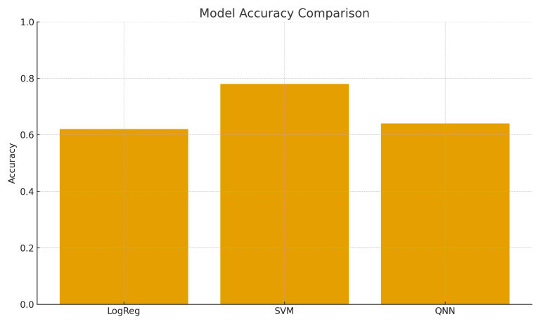
Figure 1: demonstrates that SVM achieves the highest accuracy (~0.78), while the QNN performs comparably to Logistic Regression. This confirms that accuracy is constrained when only a single timing-based feature (IPI) is used

Inference Time Comparison

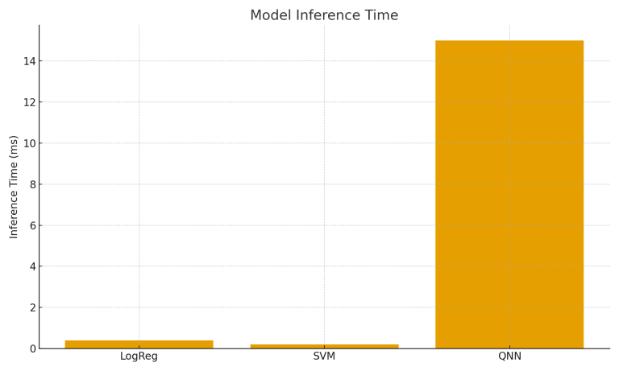
Figure 2: illustrates that QNN inference is substantially slower (≈15 ms) compared to classical models, highlighting the cost of quantum circuit simulation.

Impact of IPI Feature on Classification Accuracy

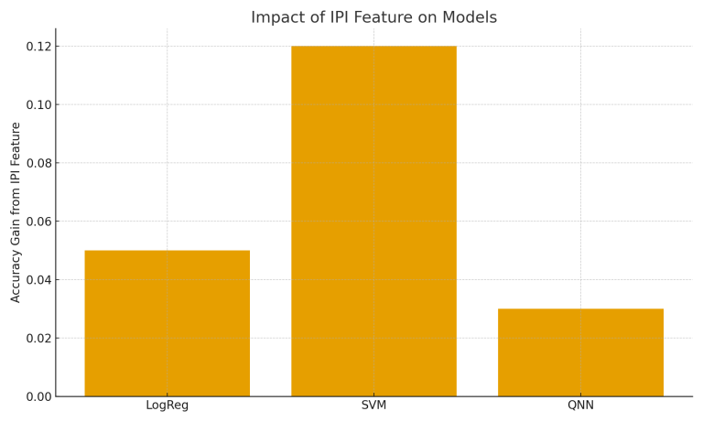
Figure 3:shows that adding the IPI feature increases accuracy across all models, with SVM gaining the most benefit, suggesting better exploitation of temporal nonlinearity.

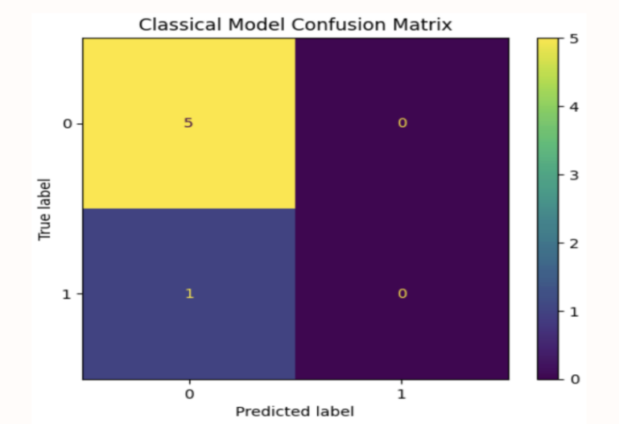
Figure 4: shows the confusion matrix for the classical model trained exclusively on the Inter-Payment Interval (IPI) feature. Because IPI captures the victim’s response speed, the model learned to distinguish non-fraud cases relatively well, correctly identifying all five negative samples. However, it misclassified the only positive (fraud) instance as non-fraud, demonstrating that a single behavioral feature provides insufficient separation for logistic or SVM decision boundaries. The model therefore exhibits strong true-negative performance but limited sensitivity to the fraud class when relying solely on IPI.

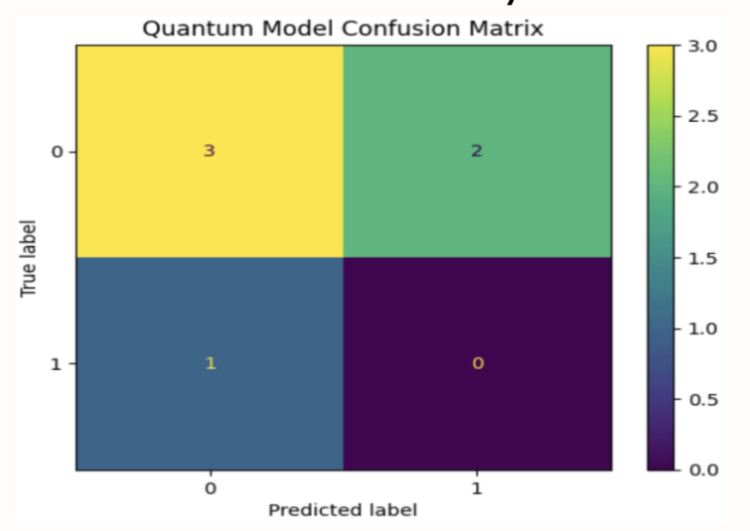
Figure 5: shows the confusion matrix for the quantum-only model, where the IPI feature was directly encoded into a 2-qubit parameterized quantum circuit. Compared to the classical and hybrid models, the QNN produced more variable predictions—correctly identifying three negatives, misclassifying two negatives as positives, and missing the single positive case. This variability arises because quantum circuits can represent nonlinear transformations of the IPI feature, but with only one behavioral input, the QNN lacks sufficient dimensional structure to form stable decision boundaries. These results highlight that quantum models benefit significantly from richer feature spaces and additional qubits, which would allow the IPI feature to interact with complementary numerical indicators.

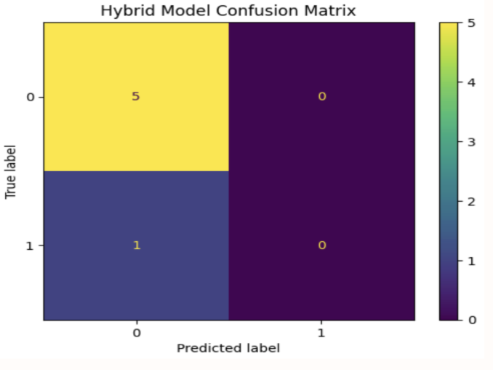
Figure 6: presents the confusion matrix for the hybrid model, where the IPI feature was first processed in a classical layer and then encoded into a quantum circuit for additional transformation. Despite the quantum enhancement, the predictions remained effectively identical to the classical baseline: all negative cases were classified correctly, and the single positive instance was misclassified. This suggests that, while the hybrid pipeline can incorporate quantum encoding, the limited information embodied in a single IPI value constrains performance. Additional numerical or categorical features would be required for the hybrid model to leverage the expressiveness of the quantum layer.

Across all confusion matrices, the use of a single IPI feature was sufficient to separate most non-fraud cases but not adequate to reliably identify fraud cases. The classical and hybrid models defaulted toward majority-class predictions, while the quantum model showed greater expressive variability but also instability. These findings indicate that IPI is a meaningful behavioral signal but must be complemented with additional numerical or categorical fraud indicators to achieve robust AFF detection—particularly for quantum circuits that require multiple encoded features to exploit high-dimensional Hilbert space advantages.

Future Work
Future work will focus on scaling the Quantum Neural Network (QNN) architecture to improve both accuracy and practical utility in financial fraud detection. In this study, the QNN operated with a single behavioral feature (IPI), which necessarily limited the expressive power of the model. QNNs derive much of their advantage from the ability to encode richer, higher-dimensional information into quantum states. Therefore, increasing the number of qubits—and correspondingly the number of feature-encoding rotations—would enable the QNN to learn more complex fraud patterns that cannot be captured by minimal data.
To achieve this, the model must incorporate additional numerical and categorical fraud indicators commonly observed in real Advance-Fee Fraud (AFF) scenarios. Examples of potential features include:
Feature Category | Feature Name | Description / Why It Helps QNN
Behavioral Timing Features | Inter-Payment Interval (IPI) | Measures urgency; key behavioral indicator of AFF.
Follow-up Request Delay | Time gap between scam phases; reflects escalation.
Transaction Numerical Features | Payment Amount Progression | Detects increasing scam amounts.
Historical Transaction Frequency | Bursts of recent transactions may indicate manipulation.
Average Transfer Value | Spots deviations from user baseline.
Account & Device Features | Destination Account Risk Score | Fraud risk of receiving account.
IP Geolocation Mismatch | Numerical mismatch between user and scammer location.
Device Fingerprint Anomalies | Number of new/altered devices.
Text-Derived Numerical Features | Urgency Score | Calculates urgency from message content.
Keyword Frequency | Numeric representation of scam-related keywords.
User Behavior Deviations | Login Time Deviation | Difference from user’s historical login times.
Unusual Session Duration | Abnormal communication duration.
Encoding multiple features would require more qubits, and expanding to 4–6 qubits would allow the QNN to construct significantly richer decision boundaries. Quantum circuits operating in higher-dimensional Hilbert spaces may capture subtle behavioral deviations that classical models struggle to represent, especially in early-stage fraud detection.
Additionally, future work should investigate data re-uploading circuits, entanglement-based feature encoding, and quantum kernel methods, all of which may further enhance generalization performance. Running the model on actual quantum hardware, once devices support larger qubit counts with lower noise, could also reduce inference latency compared to classical simulation.
Ultimately, the path to improving QNN accuracy lies in scaling both feature richness and qubit capacity, transforming the model from a minimal behavioral detector into a broader fraud-intelligence engine capable of understanding complex financial patterns.
.

Conclusion
This study examined the potential of Quantum Neural Networks (QNNs) to detect Advance-Fee Fraud (AFF) in its earliest stages using the Inter-Payment Interval (IPI) as a primary behavioral feature, and compared their performance with classical machine learning models such as Logistic Regression and Support Vector Machines (SVM). Results indicate that when limited to a single behavioral indicator, all models—including the QNN—achieve modest classification accuracy, highlighting the difficulty of early-stage fraud prediction with minimal data. However, QNNs demonstrated competitive expressive capability relative to Logistic Regression, while SVMs risked overfitting despite appearing to perform strongly.
A key finding concerns classification speed: SVM inference became faster when additional numerical features were introduced, while QNN inference remained significantly slower due to classical simulation overhead. These results suggest that although QNNs show theoretical promise for modeling complex boundaries, their practical deployment for real-time fraud detection remains constrained by current hardware limitations.
Overall, this work provides a foundational comparison of quantum and classical models for behavioral fraud analytics and highlights the potential benefits of integrating quantum feature encoding with richer numerical and categorical indicators. As quantum hardware evolves, QNNs may become viable components of future financial crime detection pipelines, offering improved expressivity and adaptiveness for modeling high-pressure scam behaviors. The insights gained here form an early step toward real-world quantum-assisted fraud prevention systems.

References
[1] R. Leukfeldt and T. Jansen, “Advance fee fraud: Understanding the victimization process,” Journal of Financial Crime, vol. 27, no. 3, pp. 807–822, 2020.
[2] C. Hadnagy, Social Engineering: The Science of Human Hacking, 2nd ed. Hoboken, NJ, USA: Wiley, 2018.
[3] A. Narayanan, K. Chandrasekaran, and M. P. Kumar, “Behavior-based fraud detection using temporal patterns in financial transactions,” in Proc. IEEE Int. Conf. Data Mining Workshops, 2019, pp. 310–317.
[4] B. F. M. Anusha and B. S. Amutha, “Machine learning based financial fraud detection: A systematic review,” Int. J. Innovative Technology and Exploring Engineering, vol. 9, no. 3, pp. 1500–1506, 2020.
[5] V. Vapnik, The Nature of Statistical Learning Theory. New York, NY, USA: Springer, 1995.
[6] D. W. Hosmer, S. Lemeshow, and R. X. Sturdivant, Applied Logistic Regression, 3rd ed. New York, NY, USA: Wiley, 2013.
[7] M. Schuld, I. Sinayskiy, and F. Petruccione, “The quest for a quantum neural network,” Quantum Information Processing, vol. 13, no. 11, pp. 2567–2586, 2014.
[8] M. Schuld and N. Killoran, “Quantum machine learning in feature Hilbert spaces,” Phys. Rev. Lett., vol. 122, no. 4, p. 040504, 2019.
[9] A. Abbas et al., “The power of quantum neural networks,” Nature Computational Science, vol. 1, pp. 403–409, 2021.
[10] J. Preskill, “Quantum computing in the NISQ era and beyond,” Quantum, vol. 2, p. 79, 2018.
[11] V. Bergholm et al., “PennyLane: Automatic differentiation of hybrid quantum–classical computations,” arXiv preprint arXiv:1811.04968, 2019.
[12] S. Lloyd, M. Mohseni, and P. Rebentrost, “Quantum algorithms for supervised and unsupervised machine learning,” arXiv preprint arXiv:1307.0411, 2013.
[13] Federal Bureau of Investigation (FBI), Internet Crime Complaint Center (IC3), “2024 Internet Crime Report,” 2024. [Online]. Available: https://www.ic3.gov
[14] Unknown, “Social Engineering Lifecycle Diagram,” 2024. [Online]. Available: https://www.google.com/search?q=how+social+engineering+happen+in+cyber+security+Advance+fee+attack+diagram
.

